A translator is used to convert a high level language into machine code

[2]

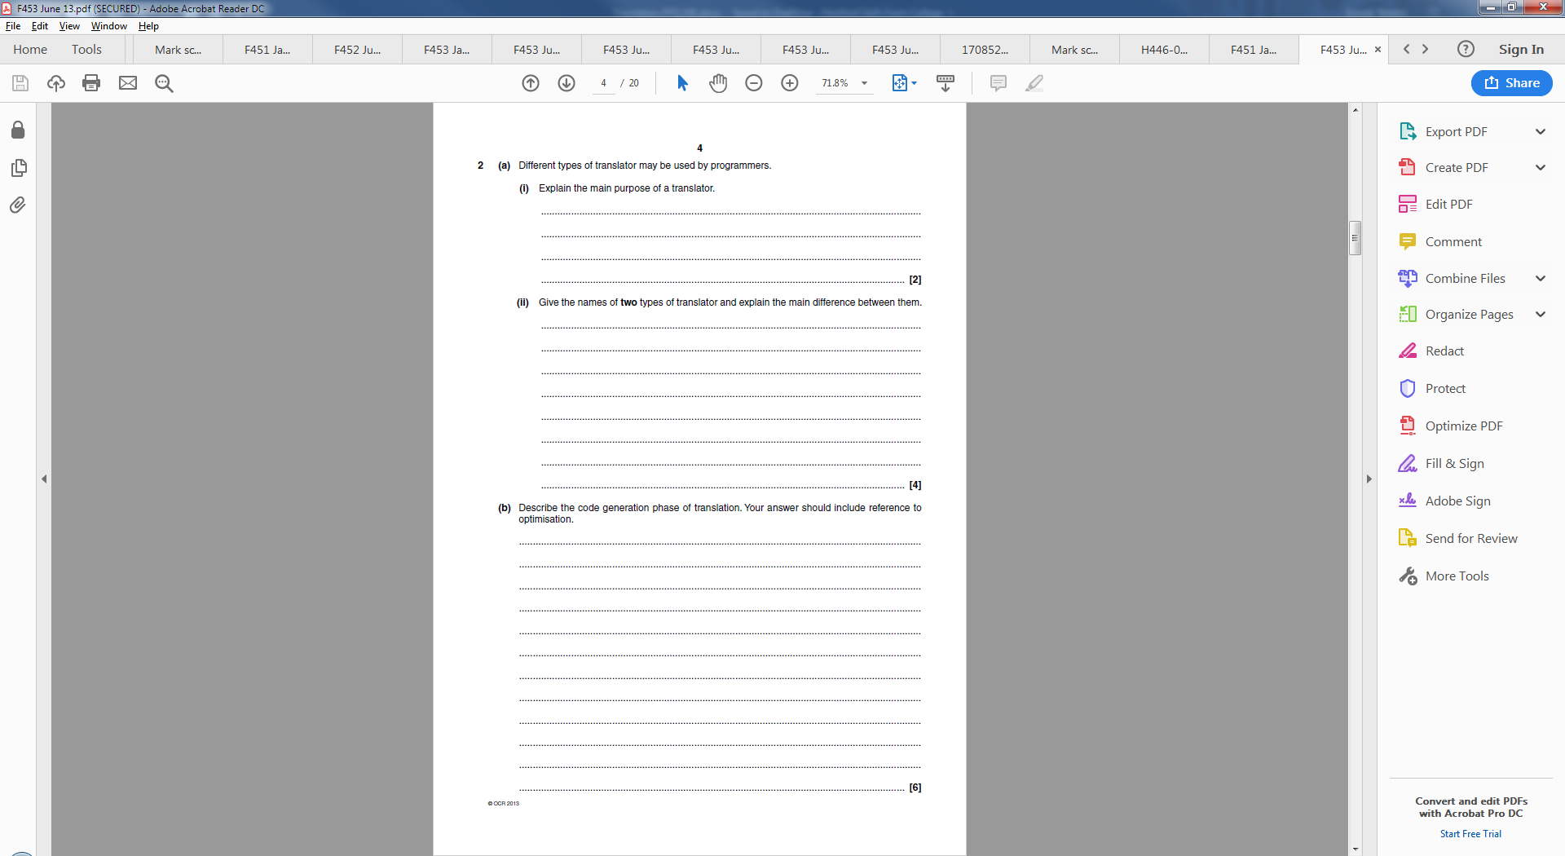

Interpretor – Code is translated on the fly line by line

Compiler – Code is translated into an executable that can be run

[4]

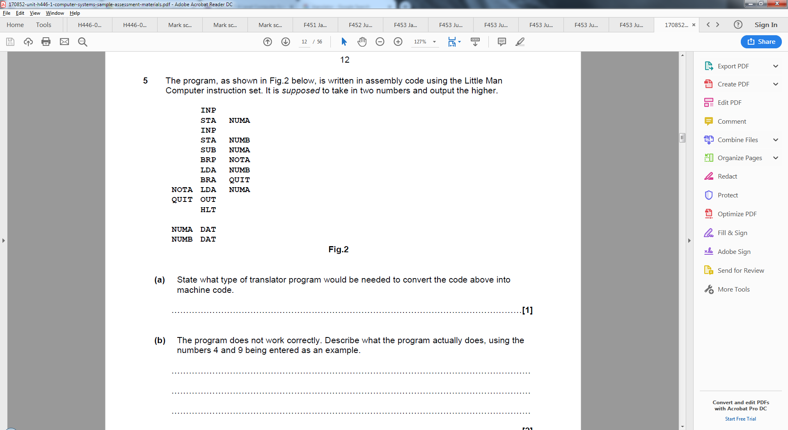

Assembler

[1]

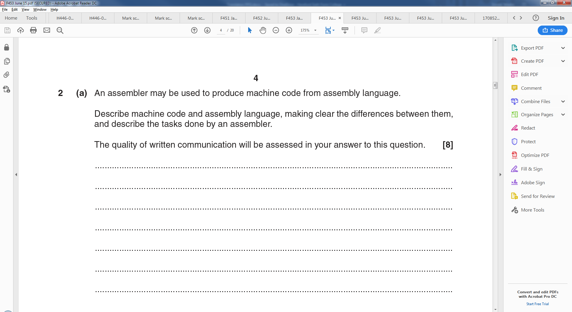

Machine code and Assembly language are

Machine code is the binary code that the computer runs.